**Climate Solutions and Sustainable Prosperity from the Bioeconomy:**

**The Case of California**

***David Roland-Holst and David Zilberman***

UC Berkeley

September 2024

California is pursuing ambitious climate goals that include significant reductions in the state’s annual C02 emissions. Decarbonizing energy production is a core component of that strategy, and while the share of renewable electric power is increasing, the transport sector energy is still dominated by fossil fuels. California currently produces an annual flow of more than 50 million metric tons (MMT) of waste biomass per year (Figure 1), the volume of which is rapidly accelerating because of efforts to contain the state’s wildfire emergency. A number of important bioenergy innovations can convert these biomass liabilities into assets for more sustainable, inclusive growth across the state. California climate initiatives also light a path for others to help reduce global climate risk.

**Figure 1: Biomass Waste Streams in California**

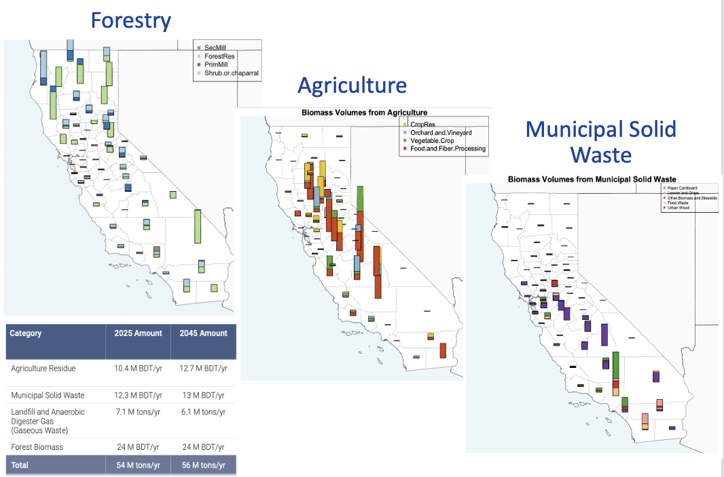

# Green Electricity

If all the state’s waste biomass were converted to electricity, the displaced carbon fuel emissions would equal half of California’s 2050 GHG mitigation goals. Despite this potential, biomass has been a chronic underachiever in the state’s power portfolio (Figure 2), with only 3% of the state’s current electric power coming from this source. Expanding the forestry biofuel sector should thus be a high priority.

**Figure 2: California’s Electric Power Mix**



# Bioenergy and Transportation

Biomass is also well below its potential to offset fossil fuel dependence, where annual consumption of 12 billion gallons of transport fuel represents California’s largest carbon liability. An important study was produced under CARB sponsorship paper and authored by Scown et al (2013). This work assessed potential GHG reductions in 2050 arising from an ambitious combined plan for electric vehicle (EV) deployment and scaling up biofuels production. This approach would tackle both the challenges of heretofore slow EV adoption and land constraints on biofuel production. The authors estimate that if 58% of cars of electric by 2050, the rest of the cars could run with an average blend of 80% ethanol and 20% gasoline. The carbon intensity of cars would then be 79g CO2e per vehicle per km traveled of electricity is supplied mostly from renewable sources.

**Figure 3: Projected total passenger vehicle fleet fuel demand (trillion MJ/year)**

Despite a late start, biomass can still make essential contributions to reducing fossil fuel dependence, particularly in ground and air transportation.

A leading Department of Energy (DOE) study estimates biomass potential within the United States, with reference to a goal of replacing up to 30% of petroleum consumption with biofuel. The report evaluates two scenarios: A Baseline that assumes the current trends continue, and a High-yield scenario that assumes aggressive deployment for biofuels. The authors highlight the importance of energy crops: when the price increases enough more farmers will decide to produce biofuels which will strongly improve the supply. The RSF target of 30% is found to be quite attainable, especially in scenarios where the price of biofuels is high.

# Bioenergy and Economic Opportunity

At the center of California’s forest biomass resources and wildfire risk, Sierra households have below average levels of income and assets compared to the rest of the state, resulting in a high concentration of DACs (Figure 6). At the same time, heating costs and more extensive transport needs mean higher energy expenditures as a percent of income. Community bioenergy development can reduce this economic vulnerability, offering locally sourced biofuels and clean electricity at comparable cost and far lower net emissions than imported fuels and power.

**Figure 6: Energy Economics of Sierra Communities**

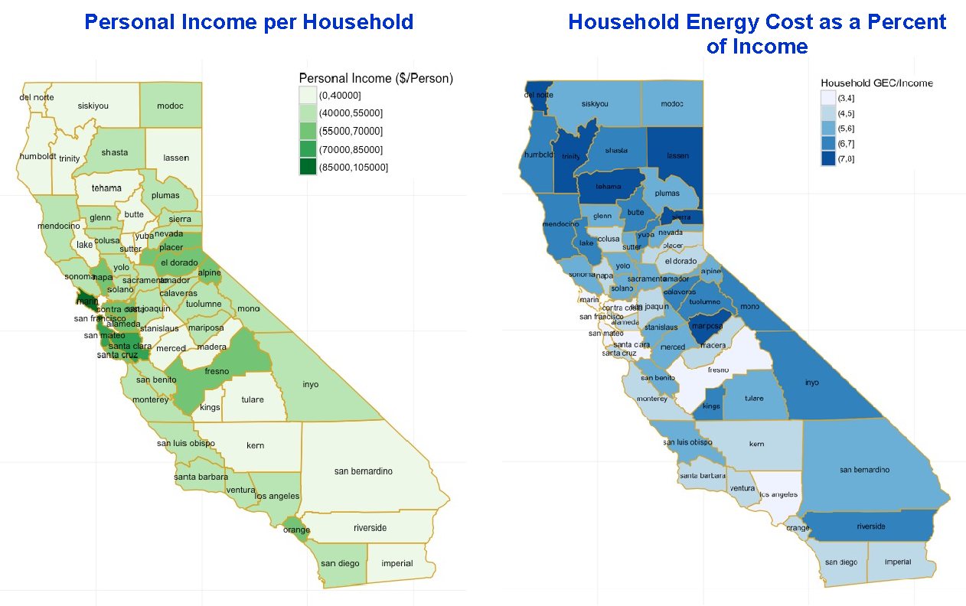

### 

# Green Fertilizer and Organic Farming 2.0: How to put California’s waste biomass to work for food security and climate risk reduction

Farm and food processing waste comprise over one quarter of the state’s waste biomass, presenting a substantial risk to the state’s greenhouse gas (GHG) mitigation goals but conversely offering substantial mitigation opportunities. Burning agricultural waste has recently been banned because of this and public health risks but hauling it to landfill merely displaces waste storage capacity while delaying emissions via decomposition. It has long been understood that recycling this material can improve soil productivity, but the traditional methods for this, direct mulching and composting, are relatively inefficient and emission-intensive, requiring storage capacity and contributing significantly to the 20% of global GHG emissions attributable to agriculture.

**Figure 1: Green Energy from Agricultural Waste**

Thanks to modern bioenergy science and technology, an alternative exists that can largely transform this waste biomass, converting it into biofuels, agrochemicals, and soil amendments that substantially reduce agriculture’s carbon footprint while robustly enhancing soil productivity, food security, and rural livelihoods. The primary agrochemical output of this process (Figure 1) is *green fertilizer* produced from biogas. This biogenic chemical has the same productivity benefits of conventional fertilizer, but it also displaces the fossil fuels usually required to produce fertilizer.[1] Beyond this innovation, other valuable products and services of this biomass conversion include waste reduction, biochar for soil amendment and carbon sequestration, and a variety of green energy services illustrated in the flowchart. Compared to composting, which directly releases highly radiative methane emissions and also presents health and sanitation risks (including rodents, other vermin, and an array of pathogenic microorganisms), gasification re-forms biogenic carbon into fossil fuel substitutes. While green fertilizer improves soil productivity and agrifood sustainability, it also displaces natural gas. Likewise, liquid biofuels can displace fossil fuels in farm mechanization, vehicles, heating, and electric power.

# Biochar Production

Biochar is a leading byproduct of bioenergy conversion and is well known for its many contributions to soil health, including a variety of ecosystem services such water retention, supporting biodiversity, and increasing productivity of the state's essential agricultural sector. Less recognized is its potential to contribute to long-term carbon sequestration, particularly through stabilization of waste biomass that would otherwise be burnt or decompose into methane and other greenhouse gas emissions. It is essential for leading state agencies, including CDFA and CARB, to recognize biochar’s mitigation potential for several reasons:

1. Biochar as a soil amendment has a long history, but conventional biochar production and recycling pathways are relatively inefficient and emission-intensive

2. While it may not offer perpetual carbon sequestration, many varieties of biochar can sequester carbon for decades or even centuries. Thus biochar can make essential contributions to California's short- and medium-term mitigation objectives, reducing the state's contribution to global warming risk until more permanent mitigation and sequestration strategies are developed and deployed.

3. California currently produces more than 54MT of waste biomass per year, representing an "emissions overhang" of organic material that threatens more immediate release methane and other greenhouse gases through burning and/or decomposition. Today, the volume of this waste is accelerating because of more determined public and private wildfire risk management strategies, while burning restrictions are increasing the biomass loads of state landfills.

Biochar needs to be officially recognized and incentivized for its mitigation potential. This will increase incentives to use biochar for healthier soils, reduce emissions from burning and biomass decomposition, and promote innovation to develop more stable and carbon-retentive biochar. Beyond this, biomass has many other higher-value uses, including carbon activation for filtration in the municipal water, food, and pharma sectors.

1. Indeed we believe biogas fertilizer produced from organically produced biomass should itself be eligible for organic certification.